Chaiwala Co.
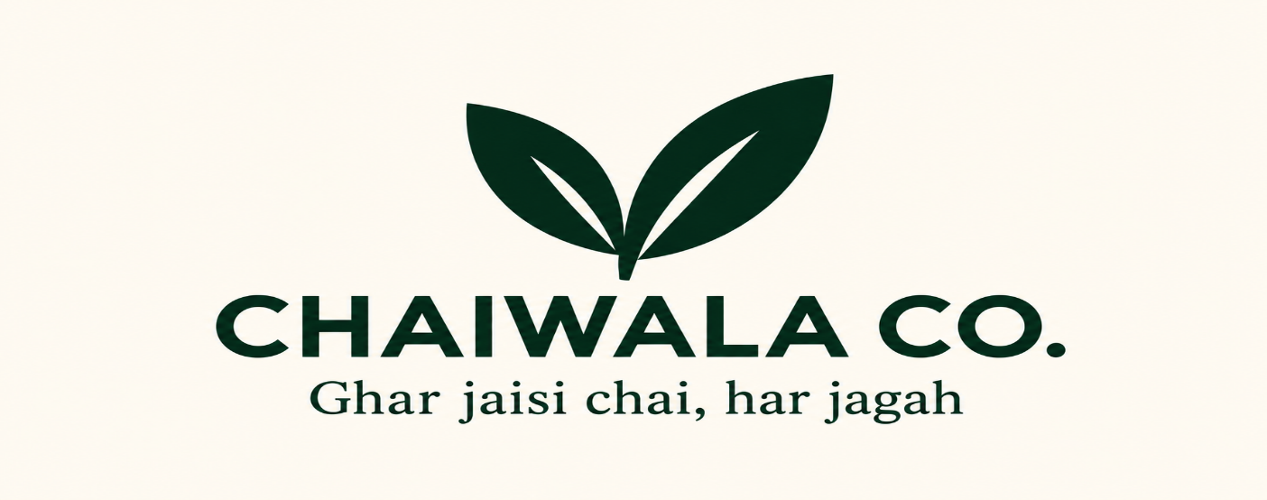

Name: Rohan Lal
PRN No. : 26030242071
DSDA

- Hostel student
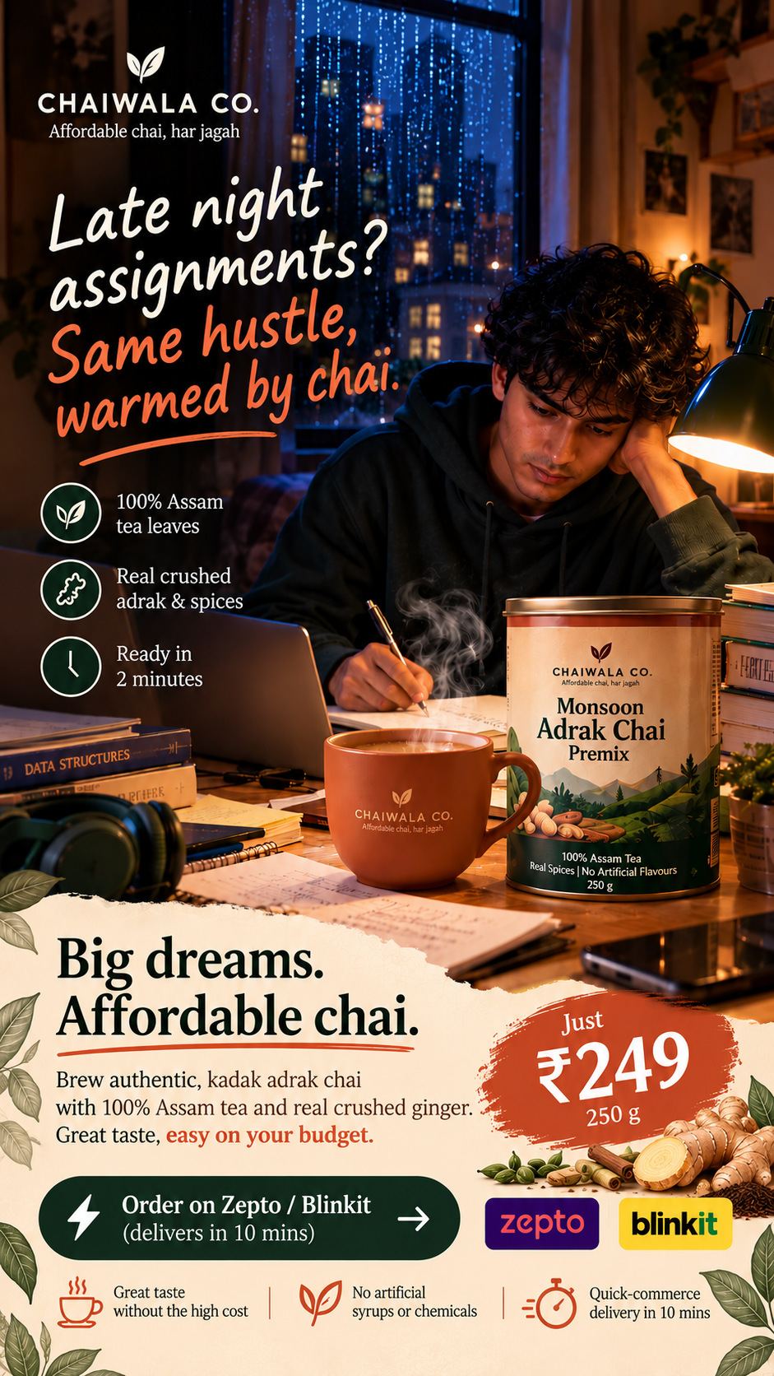

Caption : Late-night deadlines call for a comforting chai break. Authentic Assam tea, real ginger and kadak flavour, all at just ₹249.

- Young working professional 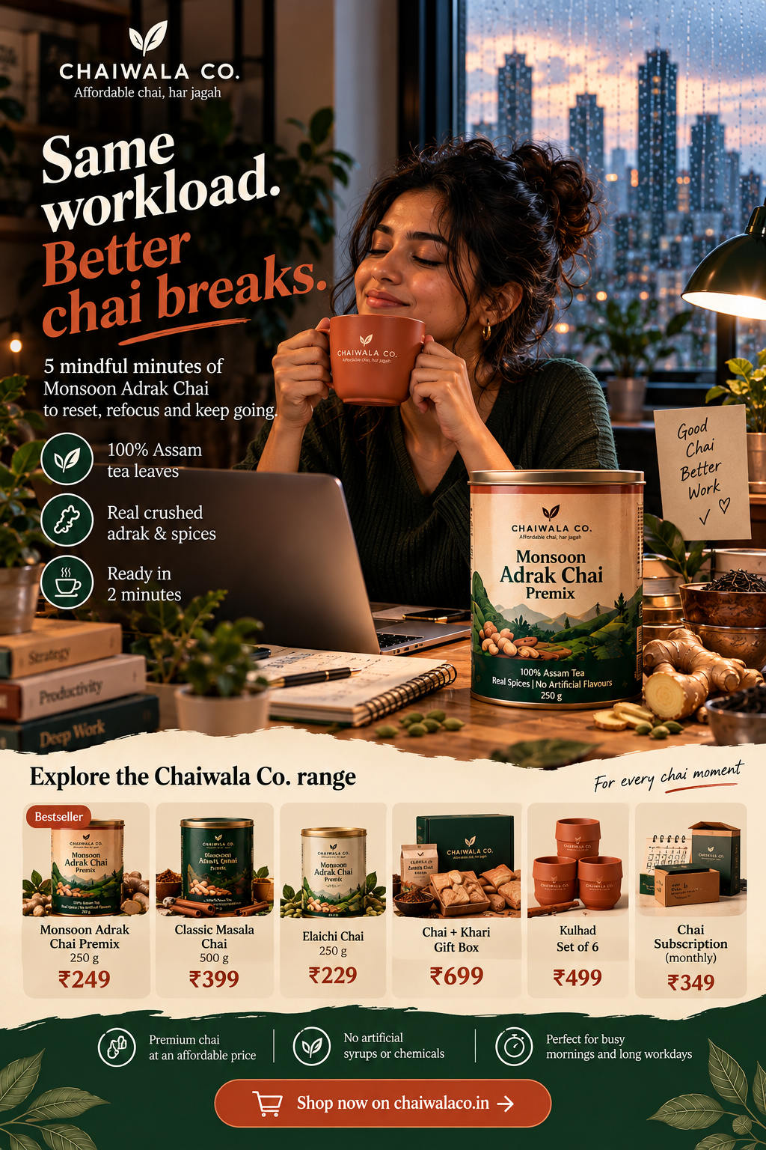n

Caption: Same workload, better breaks. Make every busy day a little warmer with authentic adrak chai. Premium Assam tea and real spices, ready in just 2 minutes.
- Homemaker
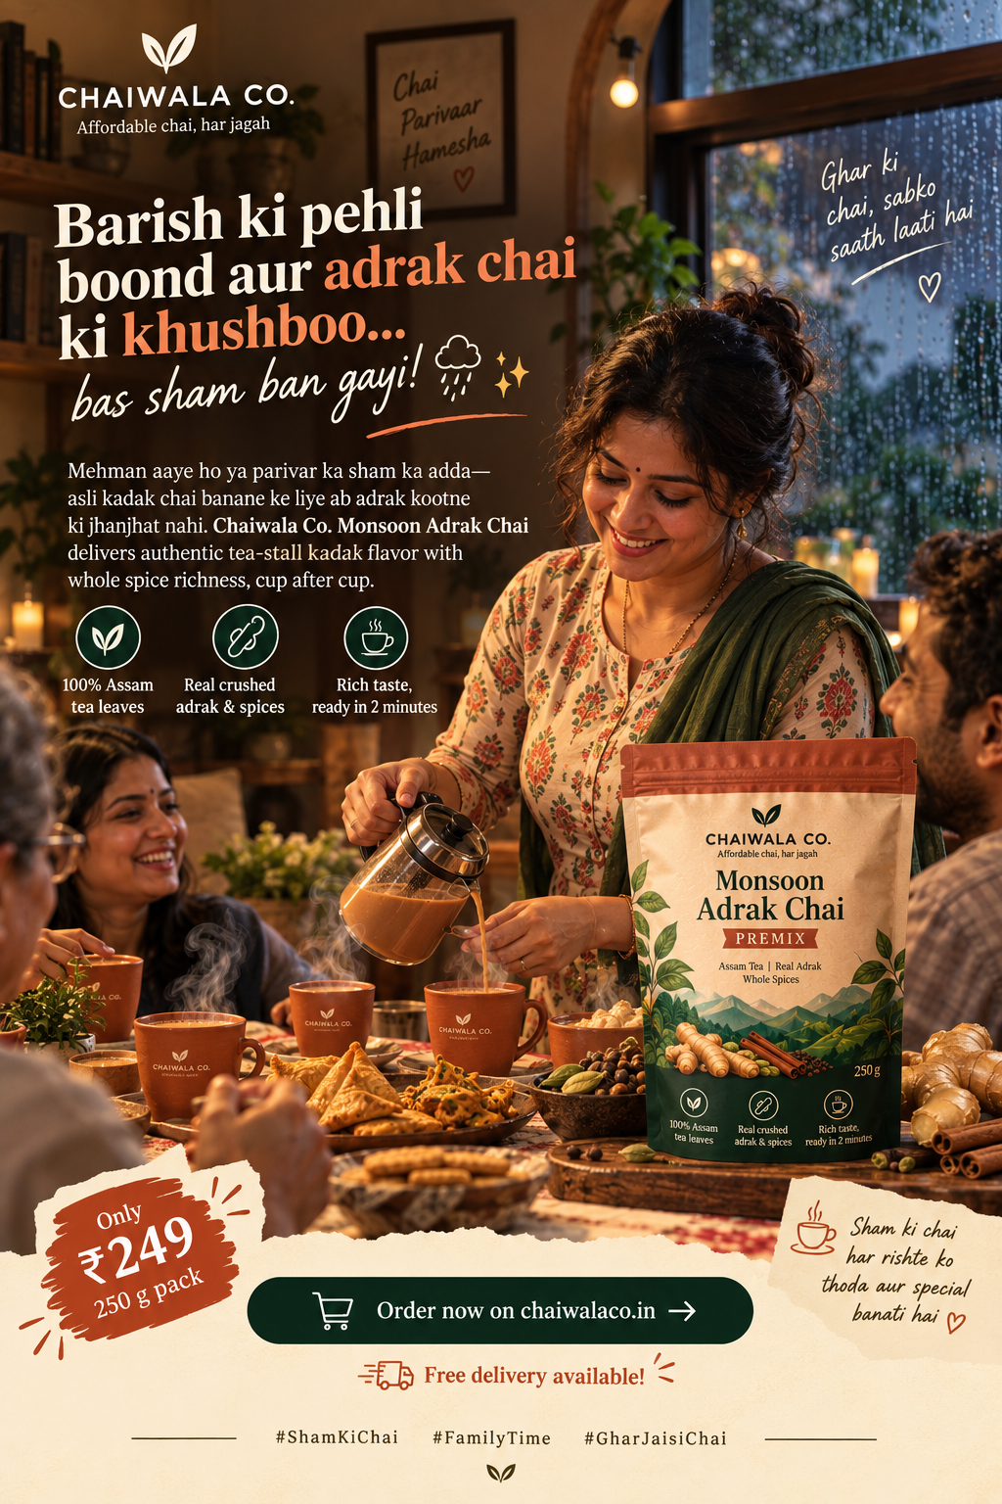
Caption: Make every rainy evening special with a cup of authentic adrak chai. ☕
From unexpected guests to family time, bring everyone together with Chaiwala Co.

- Cafe-Hopper (Instagram)
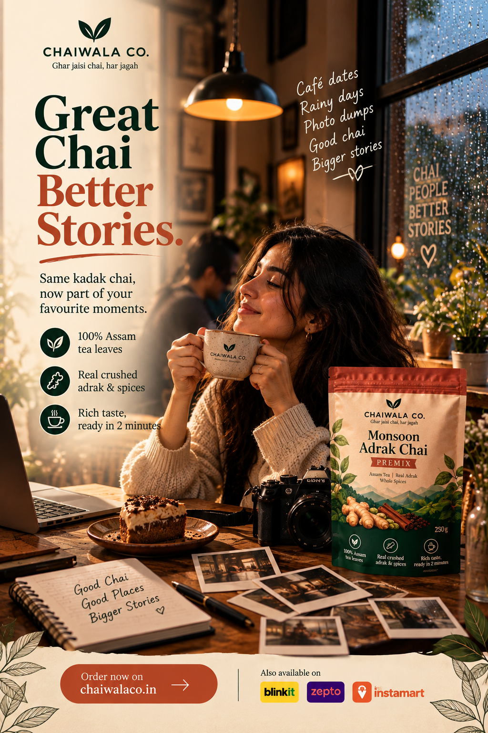
Caption: Great chai, cosy corners and moments worth capturing. 📸 Make every café date and rainy-day escape memorable with Chaiwala Co.

- Corporate Gifting Manager (LinkedIn / Email)
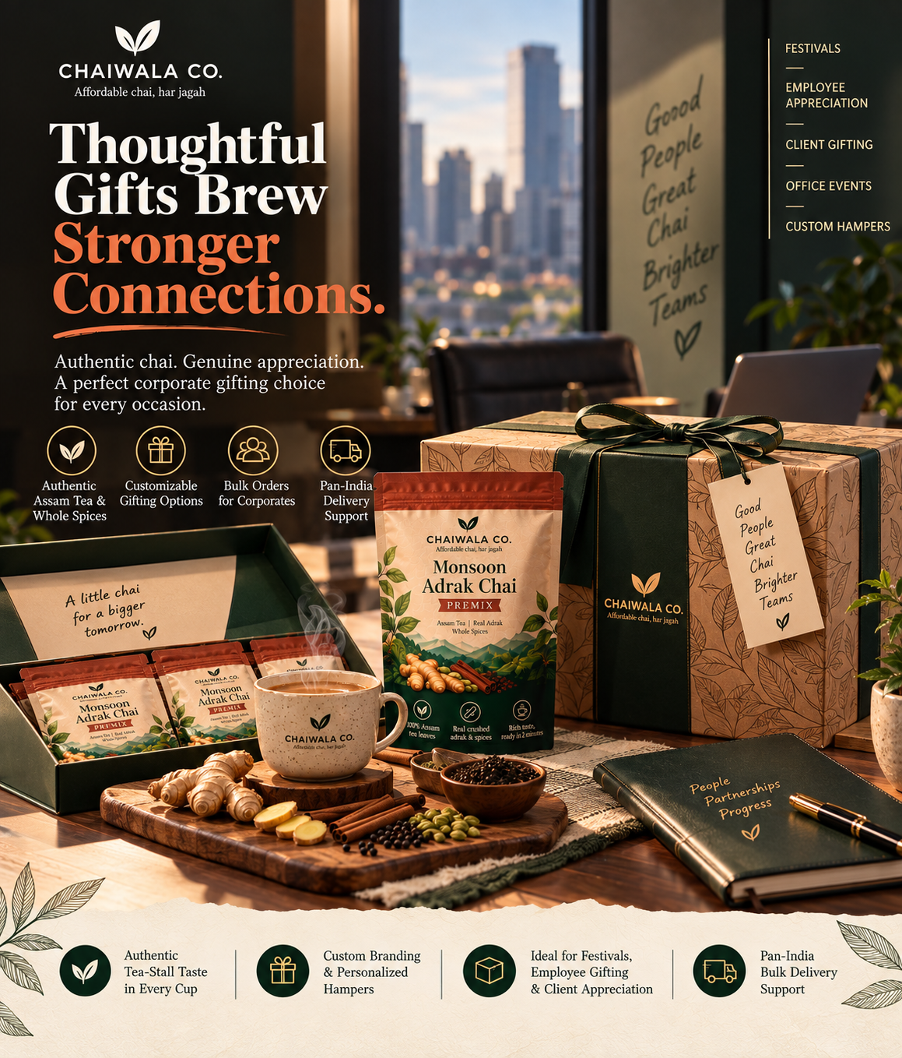

Caption: Thoughtful gifts brew stronger connections. Celebrate milestones and meaningful partnerships with Chaiwala Co.'s curated corporate gifting hampers. Authentic flavours, customizable packaging and bulk gifting options for every occasion.
6)General 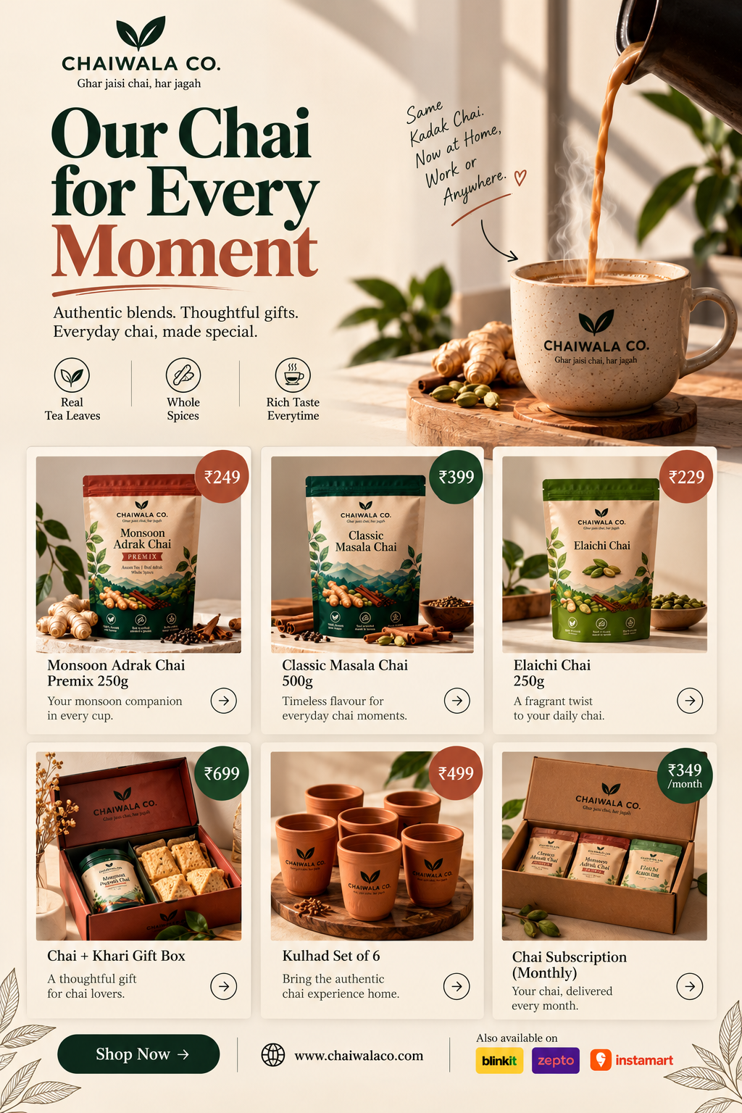
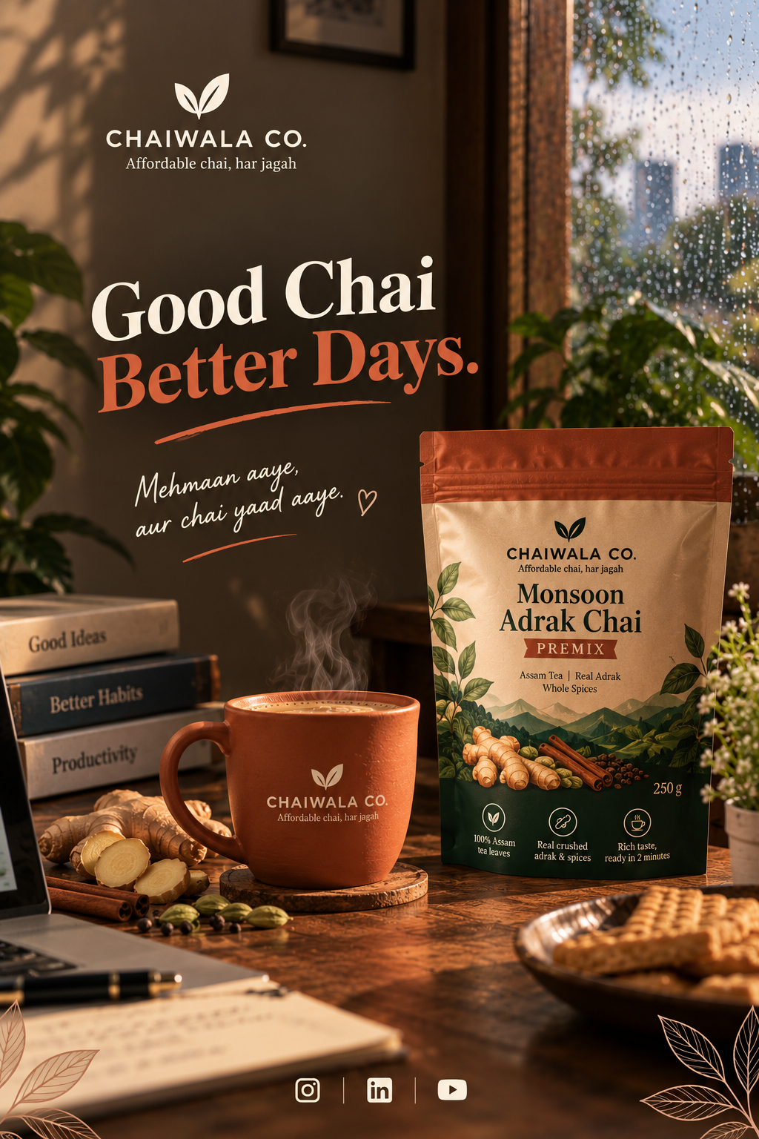
Caption: Good chai, better days. Bring home the authentic taste of Assam tea and real spices with Chaiwala Co. Explore our range of comforting blends and thoughtful gifts, crafted for every chai moment.

